Minnesota River Interview Transcript
Art & Barbara Straub
Le Sueur, Minnesota

Art and Barb Straub have carefully restored over 200 acres of land to native prairie and woodlands. Retired teachers, they frequently take students and the public on tours through their property to teach about Minnesota history, the Minnesota River, and native flora and fauna. They live near Le Sueur, Minnesota.

Changes in the Land
Clearing the Big Woods
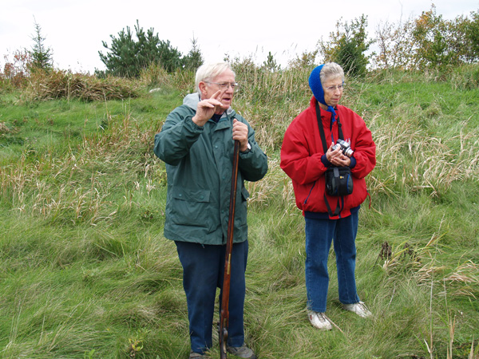
Art Straub: When I was 20 to 25 [years old], just starting to earn money, Tom [relative] was offered $30 dollars to cut that woods for lumber. I borrowed him the $30 dollars and saved that woods. We don’t think any of the trees out there are still the original trees, but that was part of the hardwood forest. This was part of the Big Woods. Then the clearing began. The first clearing would have been to make that little log place and then the rest of the clearing would have been to build the house over here and house over there.

Pasture and Trees
When I was growing up, much of it was still pasture with trees. This whole area here to the woods was pasture with trees, and another big area over there of pasture and trees. How do you think they removed stumps? What would you do if you were able to cut the trees, by hand, no chainsaws? What would you do with the stumps? Burning, horses, and one more, dynamite. In the spring of the year we would go out and stick dynamite underneath the stumps and poof! The chunks are sailing all over the place. Ma is sitting inside the house with the kids… wondering if [the kids] are coming back this time. But that’s how we removed all of the stumps in here and over in there. Before that they would have removed them with horses and other ways: the big oak, elm, and basswood stumps. The old house and the old barn--all of that was still here when we were growing up.

It’s just fantastic to think that they had their little gardens. They went to town very rarely, just for flour and a few things like that. Otherwise I can still remember: the orchard was over on this side and a huge garden on the other side. These two old spinsters [Barbara and Lizzie Straub] made their own wine [and] booze or liquor. So when they passed away, my cousin talks about going into their basement and just having a blast. I never knew Aunt Barbara or Aunt Lizzie. A lot of folks died in 1890 so I never knew those two. But we still have a primitive photo of Barbara and Lizzie. But the other part of it is, when they went to church, they went 5 miles that direction. The little church where the Straubs were baptized is 5 miles in that direction (pointing opposite way). The Catholics went down this road all the way into Le Sueur. This was the road to Le Sueur. So on a Sunday morning, my mom talked about using the bricks under your feet, and there was 9 of them. It’s hard to believe when we have our wonderful cars and trucks that we have today.

Highway 169 and Le Sueur Expansion
Art Straub: A new highway coming through your lap, and there is no way of fighting it. There was a new highway coming through [their property runs along Highway 169]. We have a beautiful little pond over here (where my dad was gored by the bull and where we collected frogs for fishing in the river illegally). They came right through the pond. Not a lot has happened now for the last 50 years. Highway 169 goes through the front yard. We had land on the other side where that Cambria [large manufacturing plant] is. Cambria eventually came into that land because when my mom died she had $8,000 dollars in debts so she sold off the land on that side of the highway but we were able to keep the rest over here and keep the rest of the farm. Now we have Cambria over there, but as you can see that water tower over there, Le Sueur intends to be here. So, that’s what we are going through now, Le Sueur has this intention of being here. They’ve purchased from the Dairy Queen all the way down to the brick building, and they are working on acquiring that land out there. I caused the 3rd world war because we are not budging. But eventually Le Sueur will be where you are now. There is a new service road that is going to come in.

Site Restoration
Art Straub: Right now as you look out there, there is 73 acres of prairie right here. This is 20 acres of these marvelous trees right here. Barb and I have 200 acres, and that’s totally prairie and trees. Our prairie is tall grass prairie where we take kids from the churches and kids from the schools. Because we are retired teachers, we [like to] take them through the tall grass prairie. It is way above their heads and they can pretend that they are Laura Ingalls Wilder, and get a taste for what it must have been like not to be able to see through the grasses. This is a short grass, it has 16 forbs in it, and16 kinds of flowers that flower starting early in the spring. The Asters just finished flowering out there, so that’s kind of pretty, but they weren’t recommending forbs when we planted so we’ve got this Blue Stem.
Well, the first thing that happened is that the land is totally put into one field of one kind of crop. This year it happens to be soybeans, and that’s happening, as you know, all over the countryside. That’s one of the reasons for the problems in the river. When 120 acres get heavy rains, like the recent 12-14 inches of rain, you’re going to see what it does to one little people’s area.

Well anyhow granny Katherine died, and they split it into 4 parts now the area you’re going to go through he was going to totally wood, the ravines and the whole smear, and take out all the big trees. This fellows wife was my Aunt Bridget. She pleaded with him to sell the land that you’re on right now to us. So we bought the 80 acres, that’s how we came into this. We still have no house, but we do have this. When you go through and think that he wanted to take everything out of here.

Land Trust
Art Straub: Barbara and I own 200 acres. If it wasn’t so soggy, we would have taken you to the Indian mounds that exist back there. There are two prominent mounds. [Our property is the last] undeveloped ridgeline between here and Henderson, and we want to keep it that way. We have a son, wonderful son, 45 years old. He loves the land as well, but looking to the future we [would like] to have some kind of a park or land trust because we are not going to be around that much longer. Today may be the day.

Ravine: Devil’s Drop Off
The Devil’s Drop Off [ravine] didn’t always used to be here. This was just a little gentle ravine while growing up. This was just a shallow little brook coming from on top. But as the land was cleared and the kind of farming that’s going on now occurred, the huge gorges began to develop: one coming from the north, one coming from the southeast. Imagine, there was a little county road on the other side that no longer exists and the land continues to cave in.
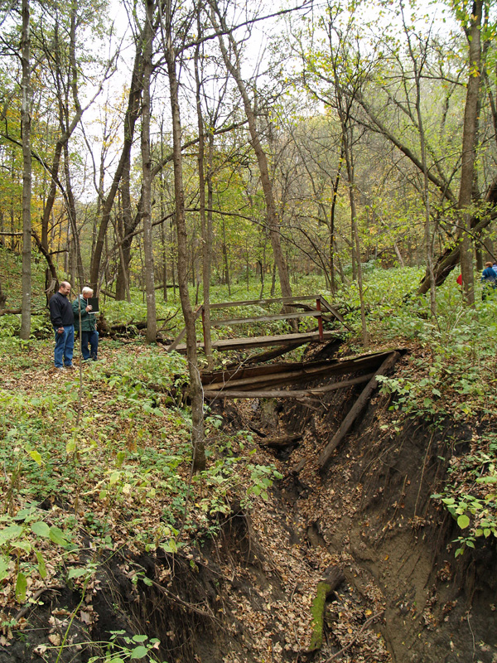

Everything was cleared, and then this [large ravine] happened. At one time the farm fields on all three sides were cleared come fall so there was plenty of runoff. When all of that land was cleared and put into the big fields, we lost the longest trunks [and largest trees]. We weren’t the owners of the property at the time, but it’s beyond comprehension what has happened here.

Upstream Changes
[Noting upstream land use patterns]
In the past few years there’s grassland on all but 120 acres so the amount of runoff even in weeks like the past couple of weeks with 10 or 12 inches of rain, the runoff has just dropped away. Our dream is this will eventually heal itself. You’ll notice there are no old trees here, this is where one road was and on the other side the road has ceased to exist, it’s dropped off into the ravine. This very same thing is going on up and down the Minnesota River Valley wherever land is allowed to lie completely bare and fallow during the winter time. This is true, up and down the valley. This is wherever you go.

Trees have begun growing and making a new ravine and repairing what was done. When it was first happening this was just a deep gouge, but it’s repaired itself. Because of the prairie grasses up above, it’s beginning to redo itself. But [the ravine] left and enormous gouge in the Earth.

There is a very little trickle that comes down here. Now the guy on top of the hill over here has put in CRP prairie also. So during the immense rains we’ve had the last couple of weeks there has just been a trickle here. So everybody has their property in prairie or grasses now, except that 120 acres, so that’s made a tremendous difference.

Ancient River
Over on the other side is where most of the water is coming off the field. A geologist was down here from the University of Minnesota. He discovered an ancient river, where a river had been, and the river ran the other direction. It didn’t go in this valley; it went out the other way. So, think of the glaciations and everything that occurred in the Earth to have, at that time, the river going that way. We found lots of remnants of an old sea, like the lime shallows and that kind of stuff. But it just boggles the mind, the forces that occurred.

Train Trestle – Sedimentation
[When I was] 20 years old, two roads came down the hill, one on the right, one on the left. A road coming down on this side, and that’s where that huge washout is now, and a road coming down on this side. They were pretty much used by the loggers and by the uncles and grandpas and that kind of thing taking wood out.
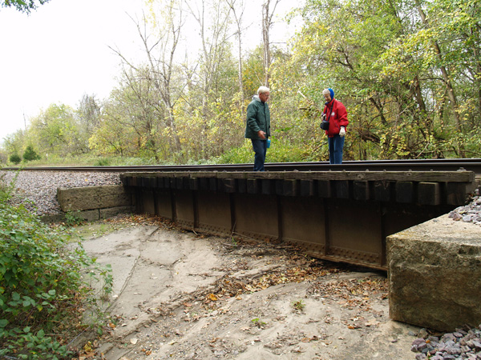

I can remember bringing a tractor down, and a car which would have been lower. Bringing the tractor under this trestle [which is completely filled with sediment now] so we have to speak of 15 feet from the base. Now this part of the trestle has never been raised, but the railroad track is continuously being raised and more logs being placed under it. The [limestone blocks] have been here since before 1900. That’s the story. We brought a tractor underneath this trestle. What does that tell you?

Railroad
This is the main trail from Mankato to the [Twin Cities] and we have always envisioned that they probably would have the trail [railroad] so we could get some of the traffic off of that highway and bring it through here. You’re walking on the railroad tracks right here.

The cattle [used to] come out of the woods and come right here. This was the cattle access to the river and over the years, where the cattle would walk down. These big culverts have dropped [significantly in elevation]. Due to the increase of housing on top the hill there’s more water that comes down the ravine. Right now the culvert piece wants to go next [fall down], and that’s going to cut us off from all of this property down here. But by the railroad, by their own admission, has a tendency to put off until the day after tomorrow, what could be done today, and we’ll show you a good example.

The river comes in close to the tracks. The railroad track ran right here. One morning my father came along and there were holes looking through the ties and a whole section of railroad had dropped out. So underneath this land, there is an underpinning of sugar sand, yellow sugar sand. When the river comes up the water infiltrates the sand; when the river goes down the sand goes out and takes that underpinning. So this is the yellow sugar sand. We had a cabin right there, twenty feet down. One day we came down and these trees are snapping and crackling and popping. We had an earthquake right here and everything just shifted down. This was our road coming in, and in the course of three years it all caved in and went to the river.

Along the Banks of the Minnesota River
[Noting bank sloughing area along Minnesota River]. See the fallen trees there now? That started when a little group of [jet skiers] came in and skied and skied and the bank began falling and falling. The mouth of Rush River [across from their property] used to be a block up river from right here but now the mouth of Rush River is here [see air photo animation]. When [early French explorer Joseph Nicollet] came through here, Dr. Bob Douglas [Geography Professor at Gustavus Adolphus College] came down with the GPS and discovered where Nicollet had his coordinates right around the corner.
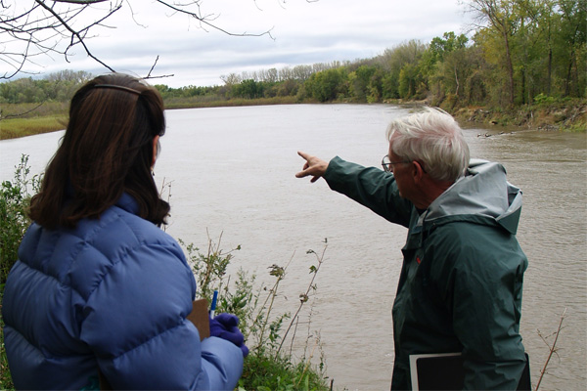

[Pointing to map] Here’s where you started out, right at this little spot, and where we are right now is right here. So you’ve come down the ravine. This is the prairie we talked about that we wanted to bring you through, that’s where we were standing this morning. This is the photo of the farm, the 400 acres we have at the moment, but much of which Le Sueur would like to have.

Fallen Trees & Trash
We were up Rush River and someone had taken, we can’t figure out what it was, but it was a cooking pot and dumped it on the bank of Rush River, thinking it’s going to go into the water, and that’s been a really prevailing attitude of a certain minority of folks; the river will take care of it. One of the things that is happening in the valley is that as the trees are cut, the branches and limbs are all left lying in the river and not removed. So in the springtime we have terrible trash kinds of things coming down the river. The all terrain vehicles are causing an immense change in our small streams that drain into the Minnesota River.

Wildlife, Fishing, Hunting
[As kids our Dad would say:] “Go down to the pond and get frogs.” There may have been hay out in the field or corn, and he would say, “boys we are going fishing.” So we would go through the ravines fishing. He would put in set lines over night. So you put three frogs on three hooks and throw them in the river, totally against the law, but we did that for years. We lived on the land: we lived off the fish in the river. Then along came the deer, because all the deer had been killed off until into the 1950’s, so then we would poach a few deer every fall. He had traps in the river, and traps were a round wire where the fish can swim in one end and can’t get out the other.

As soon as the ice was out in the springtime of the year, our father (Micah’s Great Grandpa) Todd goes out in his boat to pick up the fish, and he has a big sack full of fish from the river. Around the corner of our little cabin down there came three game wardens. We’ll take those Mr. Straub and he turned around and threw them in the river and said oh that was water cress. So they didn’t have the evidence, but he spent the night in jail, our Pa. On [my parents] 25th wedding anniversary I came home, “where’s Pa?” “He’s in jail,” says Ma. It cost 100 bucks to get Pa out of jail at that time. Today it have been 1,000 dollars and whatever but he was feeding his kids. He fed all the people up and down the valley in the springtime. They all got northern and walleye and carp and suckers and that kind of stuff. So anyhow, the [game] wardens tried to get the boat and Micah’s dad hid the boat ‘til it was over. So, we had [the boat] in the family 50 or 60 years now, and it still goes in the river.

Birds
This is the habitat of the little wren whose name we don’t have yet. When he or she comes out they just bounce around and I’ve been trying to take a photograph of it for three weeks but it’s just eluded us. So we have a wonderful mystery.

Fungus
[Referring to fungus on tree] You’ll only find it in the autumn and it is edible but the bugs have been in there pretty heavily.

Dutch Elm Disease
About 25 years ago a logger came in and said, “you’re going to lose all of your red elms.” He was coming through from the east and it was Dutch Elm’s disease and he said that you’ll lose them. We said that we’re not cutting the trees on this property. So then we noticed that people were losing their elms so we let him come and take the 20 best ones as long as he was telling the truth that they were dying. Sure enough he came and took 20 trees and the ones that he left were gone within 2 years. The goldmine [that resulted] was that these hills were riddled with morel mushrooms and we had the golden age of morel mushrooms. A tree like this, year after year, 500 morels, and that’s the honest to God truth. Well then the disease stopped and the trickle of morels stopped as well. And now the next swath of Dutch elm is coming through and up on the hill in that green corner is one of our honey holes where the morel mushroom is coming in.

Acorns, Turkeys, Deer, Squirrels, Wood Ducks
The acorns were all gone and we thought that maybe it was just our side of the valley but we were on the other side the other day and it’s happened over there also. So you have three species of creatures that will be after a similar kind of food this winter. It’s going to be interesting; the turkey population should go way up. You’ll find 17 or 18 in a group with three females. The deer population is good and the squirrel population is very good. You’re going to have three dominant species going for the same food supply. It’s going to be an interesting year. [Many species are] looking, trying to make a living. Often wood ducks will have their nests up in the woods, where wood ducks nest. So she’ll hatch them out and attend to her 12 little babies, and they’ll coming bouncing down, “We’re going to the river, Ma.” And they’ll get to the tracks and it’s an elimination [game]. Only the fittest will bounce over that track. And we have found it time and again.

Trails
I’ve got to keep mowing, and then there are alternative trails, three more trails up through the hills where you’ll end up back in the prairie.

Family History - Early Settlement
Art Straub: My relative [John Straub] stakes a claim here in August, 1857. We don’t know how long before that he actually arrived here. In the meantime Barbara’s [Straub] people are staking claims over by Le Center, St. Henry in that particular area. Little did we know that our lines would come together eventually. So, here he is in the Big Woods and he has to clear this area and all around him are Native Americans. One of their [Indian] mounds are right there but we don’t know if they were settled in that mound at that time or not. We don’t think so. We think they moved further out into the prairie. So trees have to be cut down and [John Straub] builds a little log cabin right here.

But then a Native American comes to him sometime between 1857 and 1862 and says, Johnny boy things are getting kinda hot in the west, maybe you better go back to Pennsylvania if you like your hair or whatever. What we didn’t know was, and we just found this out the other day, that the people in Mankato were upset about the way the Native Americans were being treated as well. So it wasn’t a matter of hating the folks, it was a matter of hey, they’re being jipped, by this character who won’t let the Native Americans in to get food. We have broken all of our promises. I didn’t know that the Mankato paper, and it appears in an early edition of the Mankato paper, and in a letter to the editor stating that, “hey they are being mistreated.” So it was really no surprise when things began to happen, so John goes back to Pennsylvania. The Native Americans come to visit him by the way, and he had a cask of honey in the log cabin, and they came in and wanted some of the honey thinking it might be something else. The honey had turned to vinegar, and they drank the vinegar not an expression on their faces and left.

[Pointing to a pile of rocks.] These are rocks from the cabin I am pretty sure. They needed a water supply. Here we have the Catholics, and over here we have a Protestant who really doesn’t like Catholics because of what happened in the old country, and that theme is gonna go through the family for a really long time. This is where my mom was born. There’s a big block over there by that corn crib, and she and nine other brothers and sisters were born over there. In the meantime a guy over here was going to eventually fall for her, and a Catholic is going to marry a protestant, and that’s not gonna be good. So think of it now, my mother’s people are here. These people speak a bit of English, but there is a definite lineage between them because of religion. You’ve got Dan here, and the Linches over here.

1862 Uprising
Art Straub: The Native American comes and says you better go back so you decide to go back to Pennsylvania, but the Irish stayed. In August 1862, the uprising occurred, and 5 guys from this township, one of whom was a guy of the name Bill Leske, (he’s my great uncle and he was 41 years old). He was married to Bridget and Bill went to the defense of New Ulm. Dan is gone, but Bill is here. Dan gets shot, in all places, a horse trough in New Ulm when the Native Americans came in, along with four other people from (insert name) township. So we’ll take that segment of the story. So you have been shot. You’re dead and they wrap you up in a horse blanket, and they put you in the main street of New Ulm. They bury you there, and they run over the burial spot with the horses because the Native Americans are out there coming in and you don’t want them to find those bodies. It’s hotter than bejeebers, and the rest of New Ulm-ites go into Mankato and other places for safety. A number of days later after the Native Americans had been pushed back and the white people came back to recover the bodies. They brought them back to Le Sueur, to this area. Uncle Bill (we think) is buried at St. Ann’s cemetery. At least there is a body in his spot and a marker for him. The other four people are in other cemeteries in the area. That’s kind of how this chapter closes because the uprising is over. The Native Americans have been defeated, and all of that history follows.

Returning after Uprising: John Straub
[Holding an antique rifle]. This is your defense. This is your line of defense going across country. That’s your powder. Even to shoot a deer your gonna have to make the ball yourself and put it in. John there is a place out here flowing with milk and honey. Come on back to Minnesota. The uprising is over. And so they did. My grandfather, Sam, is born--a little baby--before they came out. So now we go to a guy named John Straub. Again, he’s one of those who doesn’t appreciate Catholics. We’ll learn more about that. So, these six kids and Nancy(Bachman?), Dan and John come out here. They live across the road there and they build a house out of the logs from the Big Woods.

Sam Straub
So John begins raising the family over here, and this little Sam, the youngest, my grandfather, begins associating with those darn Catholics. We are talking about 1870, 1880. Sam learns how to play the violin, and that’s gonna prove to be his undoing. He is associating with the Catholics and playing for funerals, where they would put the coffins in the center and dance around the people. [He’s also] playing for weddings and all kinds of things where liquor would be used. So Sam is associated with the Scully’s over here (another one of the violin people), and evidentially he got into the booze heavy.

Well Sam and his wife [Louisa] raised 12 kids over here. Four of whom died relatively soon after childbirth. One of the [family] stories was that his wife (Grandma Louisa), sends Sam down to get a casket. He comes back with the casket. Sam you gotta go again. He gets another one. Anyhow, three burials in a week for that family. John is still watching this losing going on and is very upset so he kicks my grandfather off the land. My dad was born over at Waterville. Only after old John passed was my father and the rest of the family allowed back here. There were two old sisters, Barbara Straub and Lizzie Straub living over here in this old house. When old John passed, they invited Sam back, and that’s why you are standing here today, because of those two sisters.

Barbara Straub: So we had no information at all, you know? Where they were, where the families settled, until about 2 years ago. We found out that they had settled in Wisconsin. So we took a trip and we met part of the family. Of course by now they are in their 80’s. It was just so interesting because the characteristics of the woman that we met was so similar to the Straubs.

